A TECHNICAL REPORT ON STUDENT’S INDUSTRIAL WORKS EXPERIENCE SCHEME (SIWES)

TITLE PAGE

AT
WORKS FEDERAL POLYTECHNIC,
MUBI, ADAMAWA STATE

FROM: 6TH OCTOBER, 2023
TO: 29TH JANUARY, 2024

BY
AGEEYINA SUURSHATER MANASEH
(ET/CE/ND/22/105)

SUBMITTED TO THE DEPARTMENT OF CIVIL ENGINEERING TECHNOLOGY, SCHOOL OF ENGINEERING, IN PARTIAL FULFILLMENT OF THE REQUIREMENT FOR THE AWARD OF NATIONAL DIPLOMA (ND) IN CIVIL ENGINEERING TECHNOLOGY.

MARCH 2024

DEDICATION
This work is dedicated to God Almighty the maker of heavens and Earth, the giver of life and wisdom and to my beloved parent Mr. and Mrs. Ageeyina Dominic Tyor and my beloved brother Mr. David Ageeyina and all my family members who work hard to support me.

ACKNOWLEDGEMENTS
I wish to acknowledge God Almighty for his infinite goodness, mercy and protection over my life through this training and professional program at large.
In official way I wish to acknowledge my beloved biological mother Mrs. Veronica Ageeyina for her loving and wonderful support over the phase of the event and my beloved brother Adim David Ageeyina and all my family members and friends who work hard in contact to support and ensure that he program is rated successfully and I pray that may God in his infinite mercy, guide, bless, enrich, protect and support them in the ways of their life and health status, likewise financially encounter them with supernatural break through in all phase of life.
I also wish to acknowledge my SIWES Coordinator in person of Engr. Alheri Jacob supervisor Miss Naomi Ishid for ensuring that she guide me in all buoyancy of industrial training.
I faithfully, acknowledge my Honourable Head of Department in person Engr. Yakubu Mammad and all the staff of Civil Engineering department together with my fellow course mates for their support to enhance this training a successful one. I pray that may God continue to bless and support them financially, academically though out their life time through Christ the Lord. Amen.

ABSTRACT
This technical report is based on the experience gained during my four (4) month attachment, which covers all the experience gained. The chapter one covers history of ITF, benefit of ITF, Aim and Objective, chapter two covers the introduction to site work, chapter three covers preparation of sub-grade and drainage construction, while chapter four covers the conclusion and recommendation and Lastly the references.

TABLE OF CONTENT
TITLE PAGE i
DEDICATION ii
ACKNOWLEDGEMENT iii
ABSTRACT iv
TABLE OF CONTENT v
CHAPTER ONE 1
1.0 INTRODUCTION 1
1.1 MEANING OF ITF 1
1.2 OBJECTIVE OF ITF 1
1.3 AIMS OF ITF 1
1.4 MEANING OF SIWES 2
1.5 OBJECTIVE OF SIWES 2
1.6 AIM OF SIWES 2
1.7 SIGNIFICANCE OF SIWES 2
CHAPTER TWO 3
2.1 HISTORY OF THE ORGANIZATION 3
2.2 ORGANIZATIONAL STRUCTURE 4
CHAPTER THREE 5
EXPERIENCE GAINED DURING TRAINNG 5
3.1 INTRODUCTION TO SITE 5
3.2 LAYING OF DAM PROOF 5
3.3 BLOCK WORK 7
3.4 FIXING DOORS AND WINDOWS 9
3.5 TILES FIXING 11
3.6 FIXING OF CEILING 13
3.7 EXCAVATION 14
3.8 CASTING 15
CHAPTER FOUR 17
4.1 CONCLUSION 17
4.2 RECOMMENDATION 17
REFERENCE 18

CHAPTER ONE

1.0 INTRODUCTION
The Student’s Industrial Work Experience Scheme (SIWES) is a skill training programme designed to expose and prepare students in institution of higher learning.
This skill is also meant to expose students to working manner of some organization in the country and give them the required experience and practical to know how to handle equipments and machinery that may not be found in their institution.
The SIWES programme is finance by the Federal Government of Nigeria through the industrial training Fund (ITF) board. In most case, the capital used is partially obtained from taxing the registered companies and the federal government donated the remaining funds. The SIWES as a cooperation between industrial and institutional of higher learning in Nigeria is a continuation of student studies.

1.1 MEANING OF ITF
The industrial training fund was established by the decree No. 47 of 8th October 1971, with the aim of promoting and encouraging skills and acquisition of skills in industrial and commerce with a view of generate a pool of indigenous manpower to meet the need of the economy of the country.

1.2 OBJECTIVE OF ITF
- Building of training facilities of its own in identified area of national need.
- The establishment of uniform national vocation and apprenticeship training scheme in the country.
- Bearing a proportion of direct cost of the Job and off-job training Nigeria employees.
- Organizing research students as support to other activities of the fund.
- Seeking the harmonized ITF no formal training programme with the curricular formal education institution.

1.3 AIMS OF ITF
The aims of ITF is for promoting and encouraging the requisition of skills in industrial and commerce with a view to generate a pool of indigenous trained manpower and sufficient to meet the need of the economy.

1.4 MEANING OF SIWES
The programme SIWES is the student industrial work Experience Scheme which is coordinated by the industrial training fund (ITF).
The scheme helps the students to be exposed to the practical knowledge that he might not get in school during his course of study.

1.5 OBJECTIVE OF SIWES
- To expose student to equipment practically.
- To provide knowledgeable and efficient graduates under each related field
- To increase the number of skilled workers
- To bring cooperation between the employer and the estuation so as to work hand enhanced and to know what type of student to be produced and to what extent.
- To enable the students, practice their profession even after school, not only at working level even personally.

1.6 AIM OF SIWES
- To help student to see practically what have been taught earlier in classroom.
- To reconcile theory work with that of practical.
- To enable students to practically take part in ensure greats production.
- To help student greatly to know the rule and regulation and procedure of the work.

1.7 SIGNIFICANCE OF SIWES
- It helps student to gain job experience in life
- It provides an opportunity to student to pulling human relation forest by exposing students to actual working environment.
- It helps student to be skilled and knowledgeable in handling industrial equipment and tool.
- It helps students to apply principle taught in school successful on job assign to him/her.

CHAPTER TWO

2.1 HISTORY OF THE ORGANIZATION
The Federal Polytechnic Mubi is one of the seven (7) Federal Polytechnic established by Decree No.33 of 1979.It stated at August of the same year as the federal polytechnic Yola. At a picture location on the rocky side of the north bank of Benue River. Following a presidential directive, the polytechnic relocated to Mubi in October, 1982 but still maintain its site in Yola as consultancy service unit.
In Mubi the institution inherited the building of the defunct Federal School of Arts and Sciences. At present the infrastructures so inherited are being renovated and refurbished to suite Polytechnic requirement. More recently however, completely new science and engineering laboratories, workshops and studios have sprung up with heavy machines telling the tales of modern technology. A standard lecture theatre, a library complex, a duplex office block for the School of Business and General Studies, a block of offices and classrooms for the department of Basic and Applied science, Agricultural Science complex, Food Science and Technology complex and additional female hostel block among others, are now also in place.
The Federal Polytechnic, Mubi, the foremost educational institution of its type in the north-east sub-region, school system running various programs in several disciplines at the level of Higher National Diploma, Higher Diploma, National Diploma and Certificate. There are also Sandwich Programs offered during the long vacation addition to the planned Bachelor of Technology (B.Tech.) degree program. The polytechnic has six (6) schools and a centre of Entrepreneurship Education.
Since inception the polytechnic endeavoured to empower so many with both the technical and entrepreneurial skills needed to fight and alleviate poverty. Federal Polytechnic Mubi is determined to keep striding forward.

2.2 ORGANIZATIONAL STRUCTURE
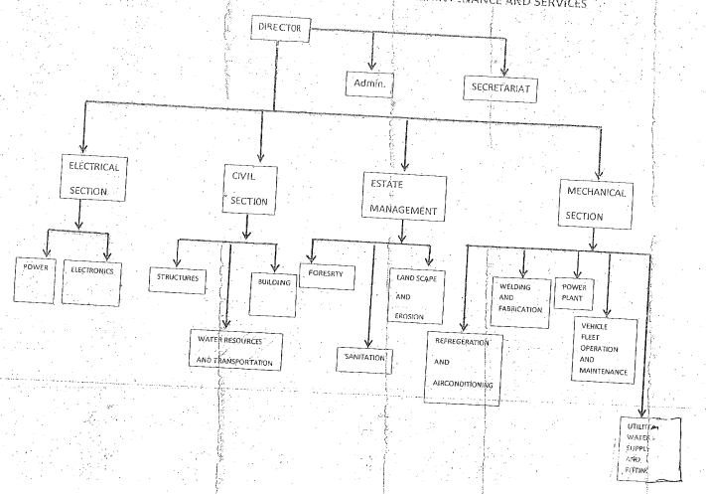
Figure 2.1: Organizational Chart

CHAPTER THREE

EXPERIENCE GAINED DURING TRAINNG

3.1 INTRODUCTION TO SITE
A site is a place of construction where the work is undertaken, it is usually associated with engineering work.

3.2 LAYING OF DAM PROOF
Dam proofing is a critical aspect of construction, especially in structures where water ingress poses a significant threat. The implementation of a Dam Proof Course (DPC) and a Dam Proof Membrane (DPM) is essential to prevent water seepage and dampness within buildings. This report outlines the process and significance of laying DPC and DPM in construction projects. The primary purpose of laying a Dam Proof Course and Dam Proof Membrane is to provide a barrier against moisture penetration. This prevents dampness, mold growth, and structural deterioration, thereby ensuring the longevity and integrity of the building.
Materials Used
Dam Proof Course (DPC): Typically made of materials such as bitumen, EPDM (Ethylene Propylene Diene Monomer), PVC (Polyvinyl Chloride), or other synthetic compounds, Available in rolls or sheets, Resistant to water penetration.
Dam Proof Membrane (DPM): Often composed of polyethylene or bituminous materials, Available in rolls, Provided an impermeable layer against moisture.
Procedure
- Ensured the surface was clean, dry, and free from debris.
- Cut the DPC material into appropriate lengths according to the dimensions of the area to be covered.
- Laid the DPC horizontally at the base of the walls, ensuring it overlapped at joints and corners.
- Used an adhesive or mortar to fix the DPC securely in place.
- Ensured proper bonding with the substrate to prevent any gaps or air pockets.
- Rolled out the DPM material over the entire surface area, ensuring sufficient overlap between adjacent sheets.
- Secured the DPM at the edges and joints using adhesive or tape.
- Inspected the installed DPC and DPM for any tears, gaps, or imperfections.
- Prevented water seepage through walls and foundations, thereby preserving the structural integrity of the building.
- Enhanced the durability and lifespan of the building by protecting it from water damage.
- Recommended regular maintenance and inspection of DPC and DPM to address any wear and tear promptly.

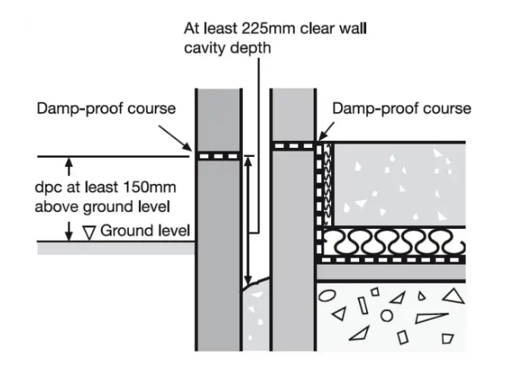

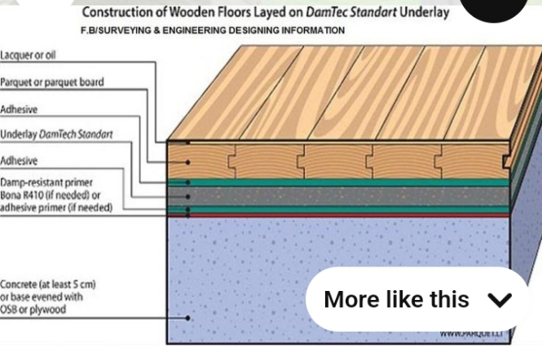

Plate 3.1: Diagram showing DPC and DPM

3.3 BLOCK WORK
Block laying is the process of arranging and securing individual blocks or bricks in a specific pattern to construct walls, partitions, or other structural elements in buildings or civil engineering projects. Blocks were moulded in number of sizes various composition, strength and shapes as 9 inches and 6 inches. Where the 9 inches were used for external walls, 6 inches for internal walls. After foundation work is finished the block work was built to cover the spaces as well. All the block work is not carrying any load, they were erected to cover spaces and also partition wall.
PROCEDURE
- Before starting the block laying process, the site was prepared by clearing debris and ensuring a level foundation.
- The layout of the walls or structure was marked using chalk lines or strings to guide the placement of the blocks.
- Blocks or bricks were selected based on the desired strength, size, and aesthetic requirements of the project.
- Mortar was mixed according to the specifications, typically using a combination of cement, sand, and water.
- A layer of mortar was spread evenly along the foundation where the first course of blocks would be placed.
- A level was used to check the horizontal and vertical alignment of the blocks.
- Once the first course was laid, additional courses of blocks were added on top, following the same process.
- Each block was buttered with mortar on its ends before being placed to ensure a strong bond between the blocks.
- Blocks may have needed to be cut to fit around corners, openings for doors or windows, or to maintain the desired pattern.
- Excess mortar was scraped off the joints using a trowel, and any gaps or voids were filled to create a smooth, uniform surface.
- Once the block laying was complete, the work area was cleaned up, and any excess materials or debris were removed from the site.

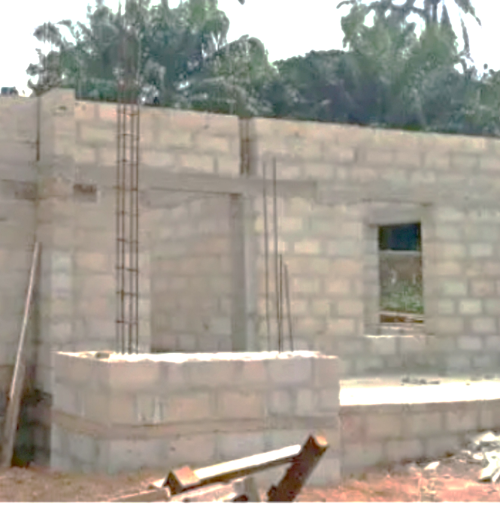
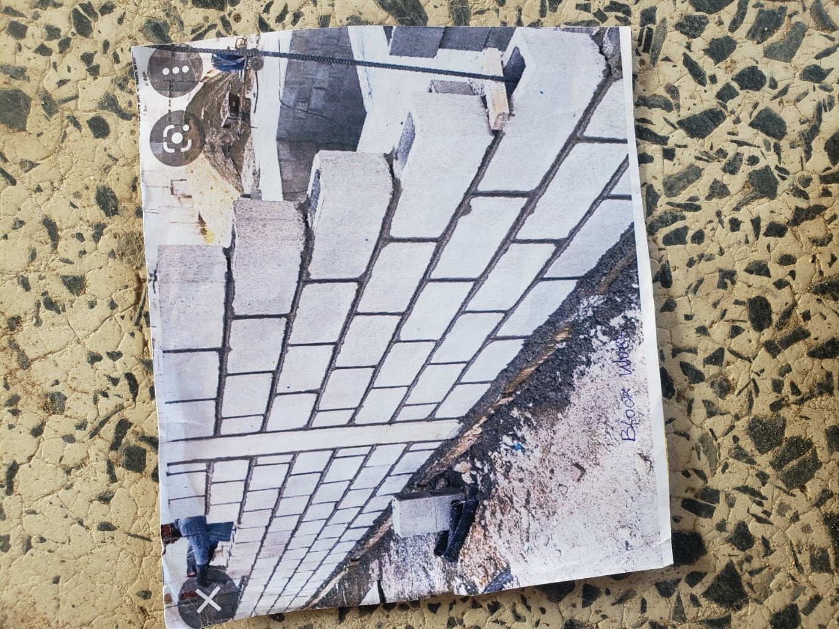

Plate 3.2: Block work
Source: Author’s work, 2023

3.4 FIXING DOORS AND WINDOWS
Fixing doors and windows was a crucial aspect of construction or renovation projects. Proper installation ensured functionality, security, and energy efficiency. Below were the steps involved in fixing doors and windows:
STEPS FOR FIXING DOORS AND WINDOWS
- The door or window frame openings were ensured to be clean, free from debris, and properly sized to accommodate the new fixtures.
- The width, height, and depth of the door or window frame openings were measured accurately.
- The frame was secured in place using shims and screws, ensuring it was securely anchored to the surrounding structure.
- The door or window was secured in place by screwing it into the frame, ensuring it was firmly anchored.
- Insulation was applied around the perimeter of the door or window frame to prevent air leakage and improve energy efficiency.
- Hinges, handles, locks, and other hardware were installed according to the manufacturer's instructions.
- The door or window was opened and closed several times to ensure it operated correctly and smoothly.
- Paint or stain was applied to the door or window frame, as well as any surrounding trim, to match the existing aesthetic and allowed to dry before using.
- A final inspection was conducted to ensure the door or window was properly installed, sealed, and functioning correctly.
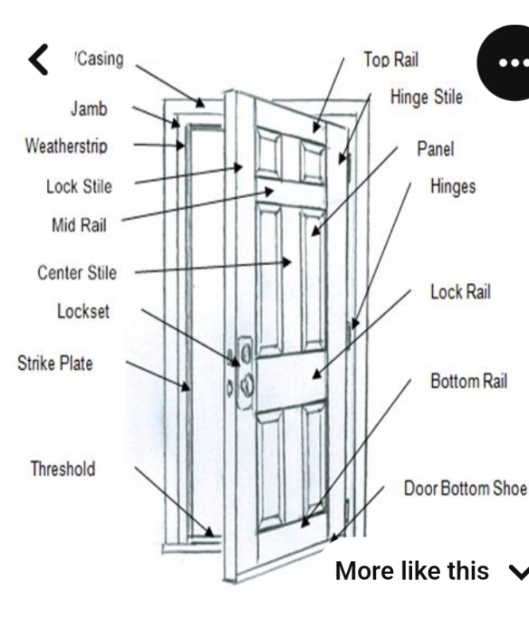

Plate 3.3: Fixing of door
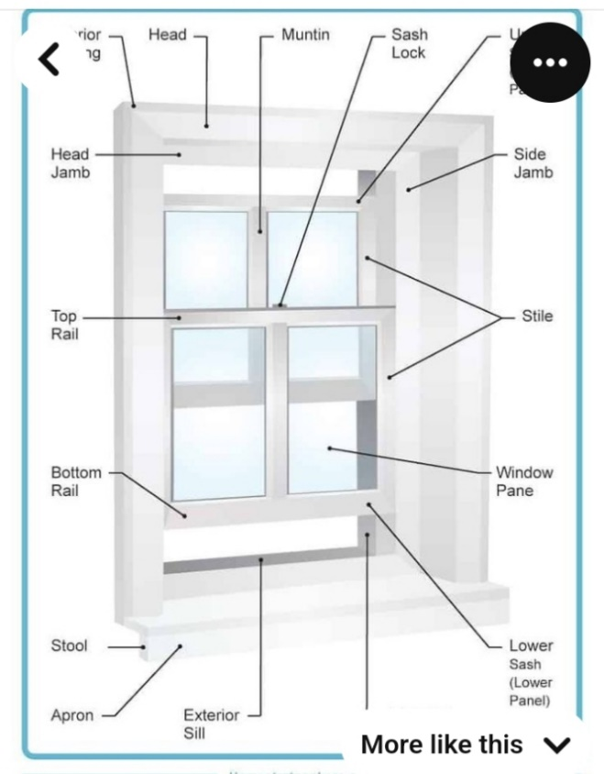
Plate 3.4: Fixing of Window

3.5 TILES FIXING
Before fixing the tiles, we laid them out in the desired pattern and mad sure that they gave an acceptable blend of shade, colour & design. Also, we made sure that the tiles were acceptable to our satisfaction.
Procedure:
- Safety gloves and safety glasses were put on to protect against potential debris during the preparation process.
- Existing flooring, which included vinyl, was carefully removed using a pry bar, hammer, and utility knife. Care was taken not to damage the subfloor underneath.
- The subfloor was closely examined for damage, unevenness, or protruding nails or screws. Ensured that the subfloor was structurally sound and free from rot or water damage. Damaged sections were replaced or repaired.
- A level was used to check for uneven areas on the subfloor. Uneven spots were marked with chalk lines. Low spots were filled with a self-levelling compound and patched according to the manufacturer's instructions.
- Baseboards and trim were removed from the walls to facilitate a clean tile-to-wall transition.
- The layout of the tiles was planned meticulously, with careful measurements and a predetermined starting point.
- Thin-set mortar was prepared as per the manufacturer's instructions. A notched trowel was used to apply a thin, even layer of mortar onto the subfloor or backer board.
- Tiles were laid, commencing from the predetermined starting point, while adhering to the layout plan and guidelines. Each tile was firmly pressed into the mortar, ensuring consistent spacing using tile spacers.
- The mortar was allowed to set and cure for the duration specified by the manufacturer (typically 24 hours).
- Once the mortar had dried, grout was applied between the tiles using a rubber float. Excess grout was wiped away using a damp sponge.
- After the grout had dried, baseboards and trim were reinstalled to cover the tile edges.

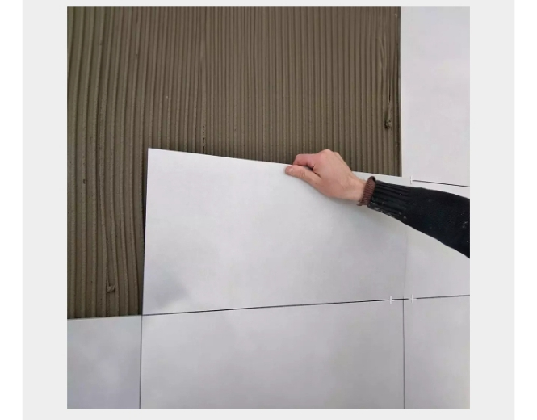
Plate 3.5: Fixing of wall Tiles

3.6 FIXING OF CEILING
The fixing of the ceiling was a crucial task undertaken to enhance the aesthetic appeal and functionality of the designated area. The ceiling, being a fundamental component of any indoor space, required meticulous attention to detail to ensure structural integrity and visual coherence.
Procedure:
- Prior to commencing the fixing process, the area was thoroughly inspected to assess any existing damages or irregularities.
- Measurements were taken to determine the dimensions of the ceiling and the materials required for the project.
- Support structures, such as wooden or metal frames, were installed securely onto the existing framework of the building.
- Ceiling panels were carefully positioned onto the support structures, ensuring uniform alignment and spacing between each panel.
- Adhesive was applied as necessary to bond the panels securely to the support structures, providing stability and preventing any potential displacement.
- Once all the panels were in place, any gaps or imperfections were addressed and filled using appropriate filler materials.
- Trim pieces were installed along the edges of the ceiling to provide a clean and polished appearance.
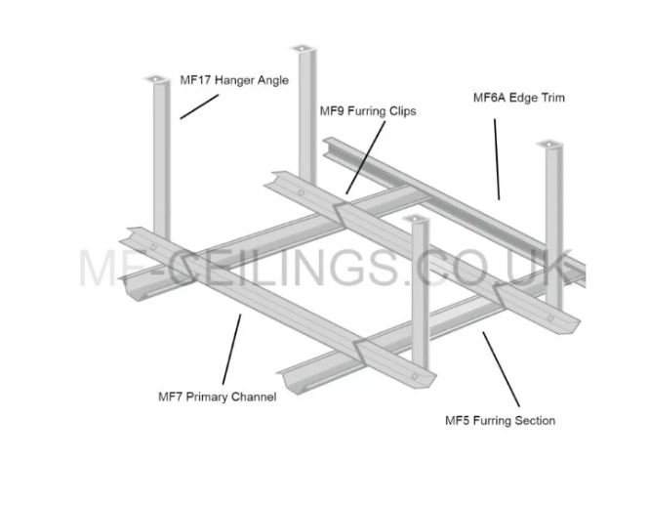
Plate 3.6: Ceiling Fixing

3.7 EXCAVATION
Excavation is the loosing and removal of earth or rocks from its original position, and transporting it to spoiled bank. It was done immediately after setting out. The excavation was done by an excavator and the drainage trench was dug to a depth of 1000mm and a width of 1000mm. Excavation can be done using two methods mechanical and manual. In small construction we normally use manual method while in large construction we use mechanical e.g. like road construction.
Excavation work were carried out manually where unskilled labourer where involved with digger, shovels, head pan and wheel barrow. The following factors must be considered when carrying out any excavation work.
- Nature of the soil
- The width and depth of foundation
- Climatic condition at the time of excavation
- The water table of the soil
- The period excavation work is expected to be left open.
- The effect of excavation on existing adjacent structure.

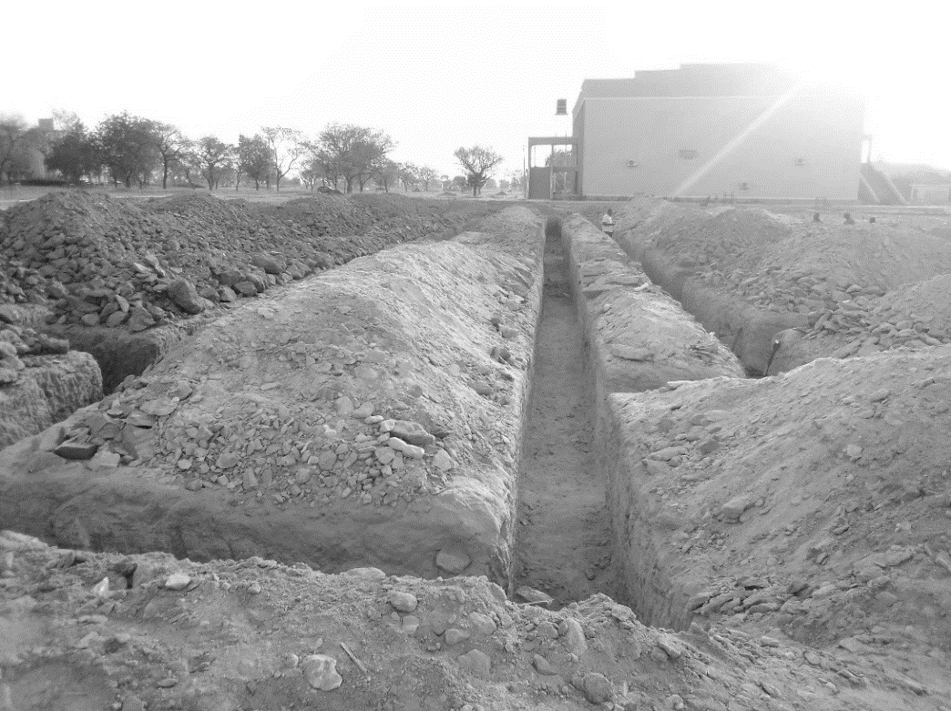

Plate 3.7: Excavation
Source: Author’s work, 2023

3.8 CASTING
Casting is a fundamental process in construction, involving the pouring of concrete into molds or formwork to create various structural elements. This section involves the casting procedures carried out for down beams, lintels, upper beams, and floors.
3.8.1 Casting of down beam
- Formwork was prepared and set up according to specifications.
- Reinforcement was placed within the formwork.
- Concrete was poured into the mold and vibrated for compaction.
- The cast down beam was left to cure before the formwork was removed.
- Any surface imperfections were addressed through finishing techniques.
3.8.2 Casting of Lintel
- Formwork was erected, and reinforcement was installed.
- Concrete was poured into the formwork and compacted.
- After curing, the formwork was stripped, revealing the cast lintel.
- Finishing touches were applied to achieve the desired appearance and dimensions.
3.8.3 Casting of Upper Beam
- Formwork was prepared, and reinforcement was placed.
- Concrete was poured into the formwork and compacted.
- The cast upper beam was allowed to cure before the formwork was removed.
- Finishing techniques were employed to address any surface imperfections.
3.8.4 Casting of Floor
- The subbase was prepared, and formwork was installed around the perimeter.
- Reinforcement was placed within the formwork.
- Concrete was poured onto the prepared subbase and leveled.
- After curing, the formwork was removed, revealing the finished floor surface.
- Surface protection measures were implemented to safeguard the newly cast floor.
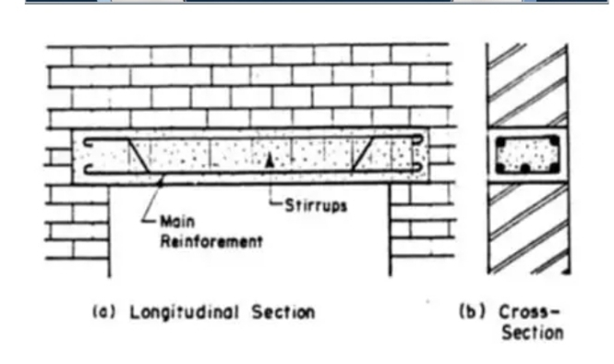
Plate 3.8: Casting of lintel

CHAPTER FOUR

4.1 CONCLUSION
The student industrial work experience scheme (SIWES) programme has expose me to bridge the gap between theoretical and practical aspect in civil engineering work. It also shaped me in acquiring knowledge and skills from the firm furthermore, it allows me to exercise my human relationship in the society by preparing me for meaningful and productive employment in future.

4.2 RECOMMENDATION
The following are the recommendations made;
- The industry should provide accommodation and also ensure that the health and security of the students on industrial attachment is provided.
- The government should increase the SIWES allowance and should be paid on time after the industrial attachment.
- The programme should continue from generation to generation respectively.

REFERENCE
Arthur, W., Peter, S. & Roy, A. (2013). Roadwork Theory & Practice, 2ND Edition
Bungey, J. H. & Mosley, W. (1990). Reinforced concrete design. Macmillan press London, fourth edition.
Burgen, T. & Mosely, W. (1990). Reinforced Concrete Design, Macmillan Press Limited, London, PP 275-569.
Neil, J. & Ravidra, K. (1996). Civil Engineering material. Macmillan press London Limited fourth edition.

